Wild
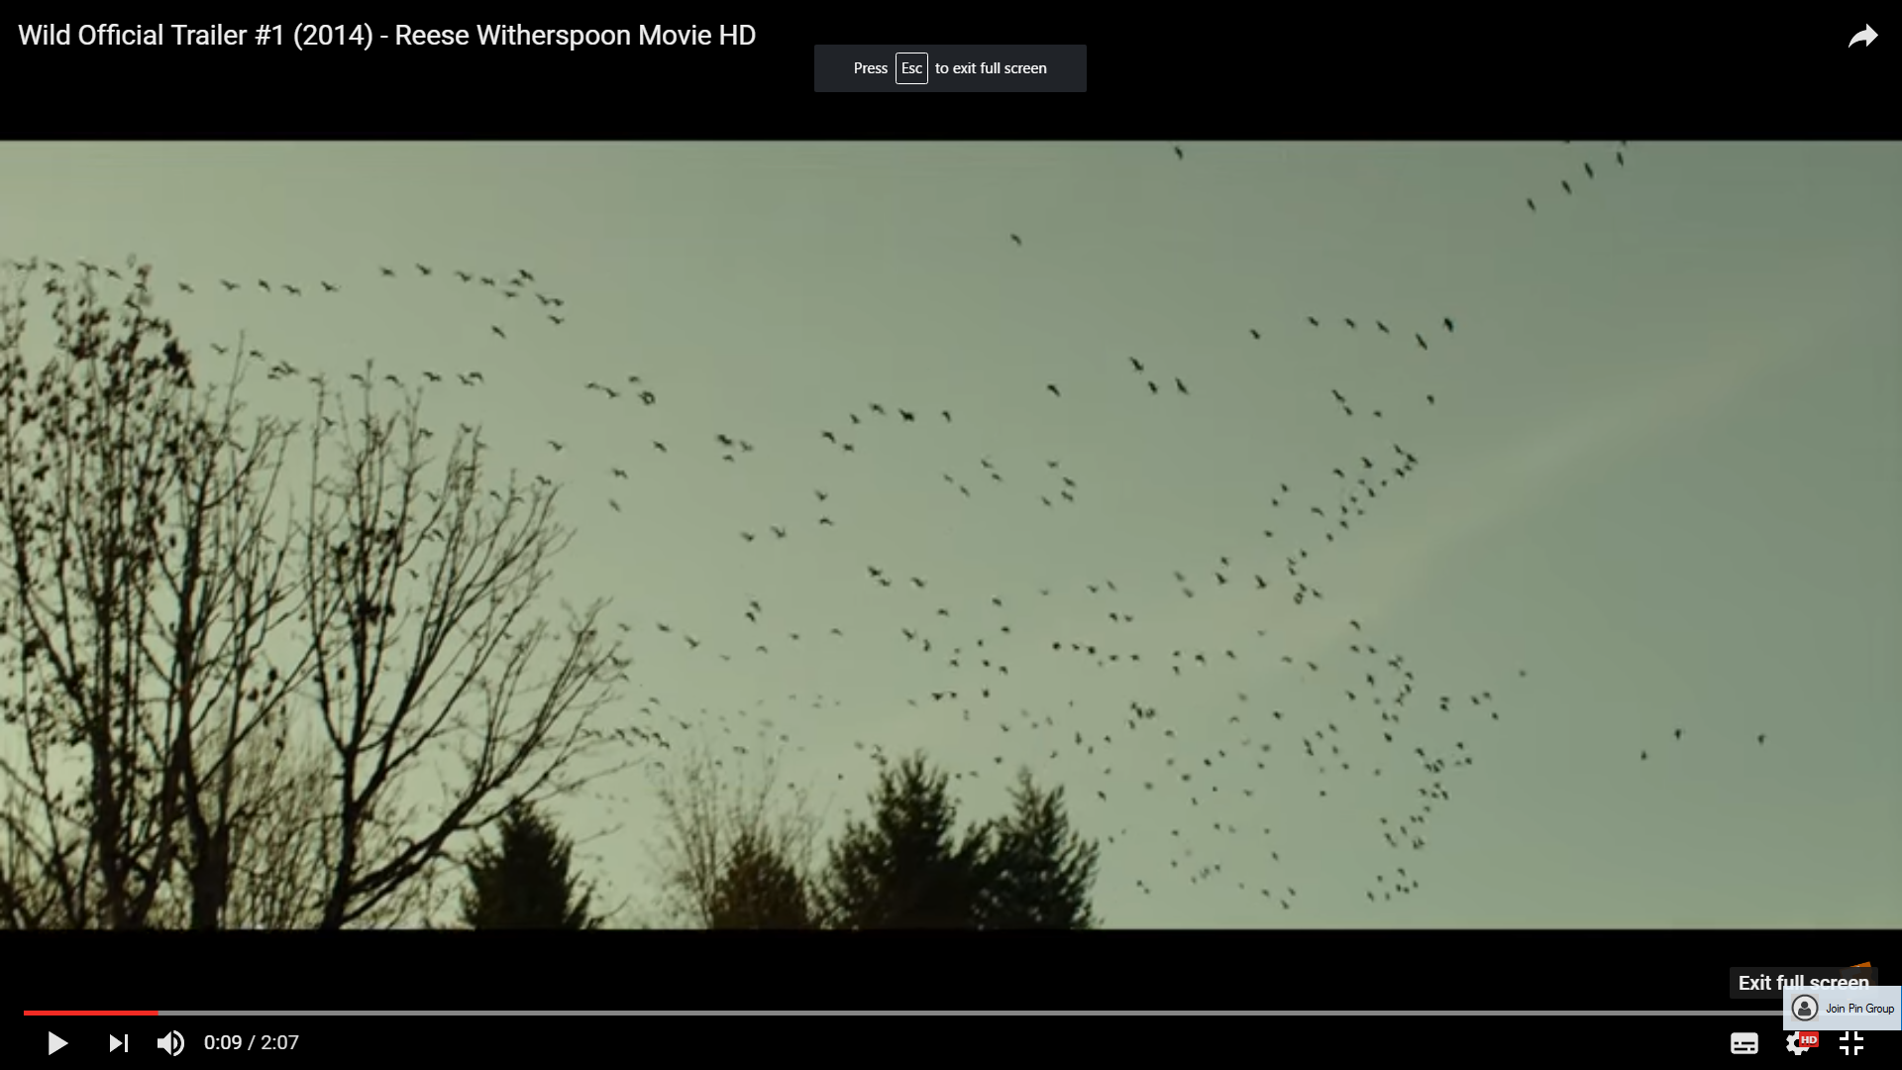

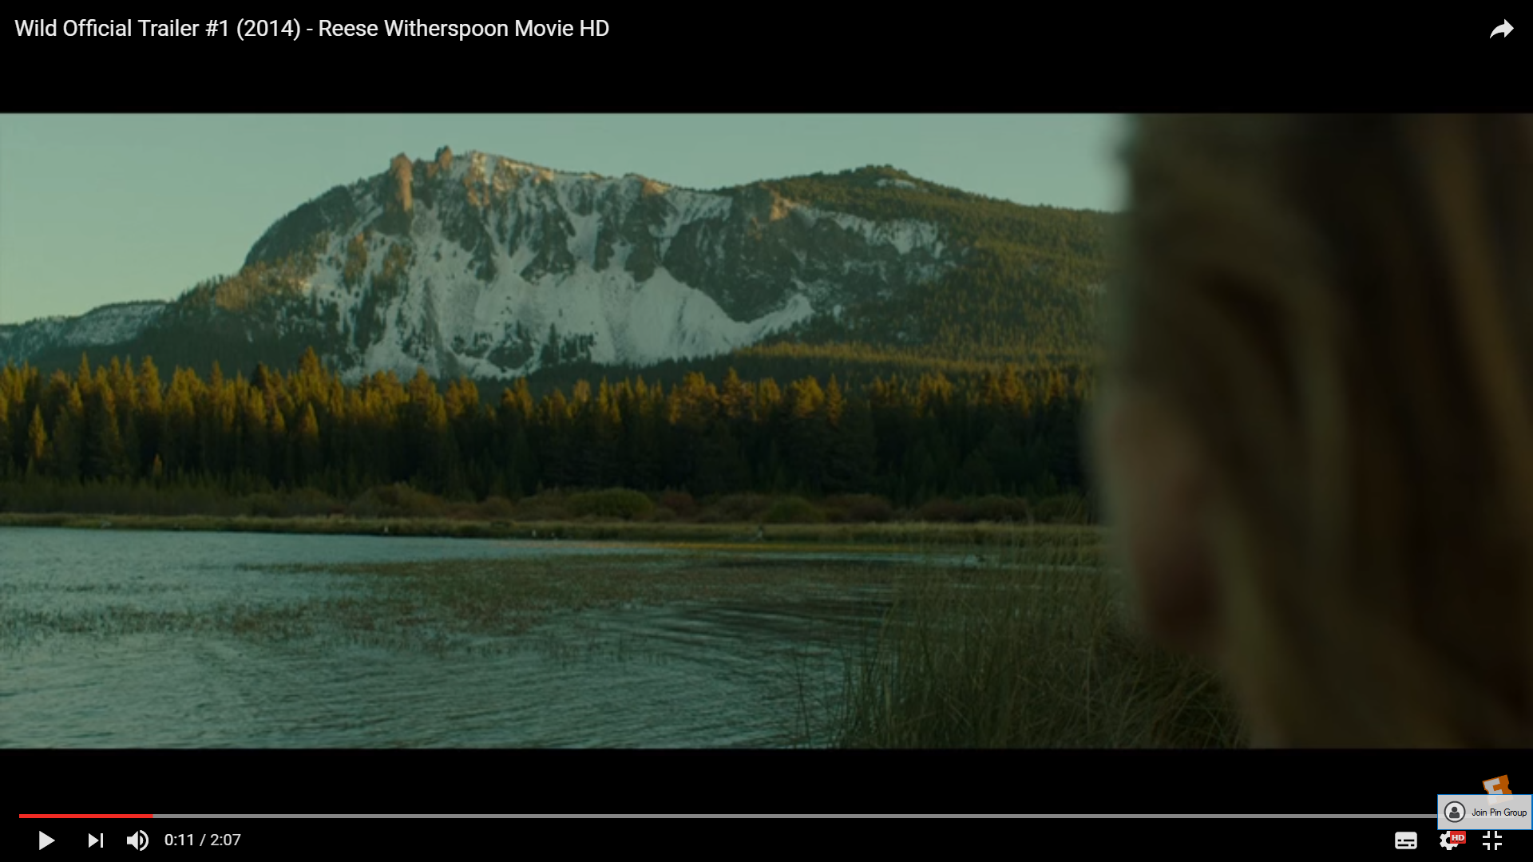

Despite all the climactic events that occur in a drama, there is more often than not a resolved ending. Throughout the drama hope is suggested through scenic shots such as these. The use of the wide shots provide a tranquil effect, it juxtaposes with the drama of the plot, however, brief shots such as these create a balance within the story - this also links to the reality of dramas as nothing stays bad for too long.

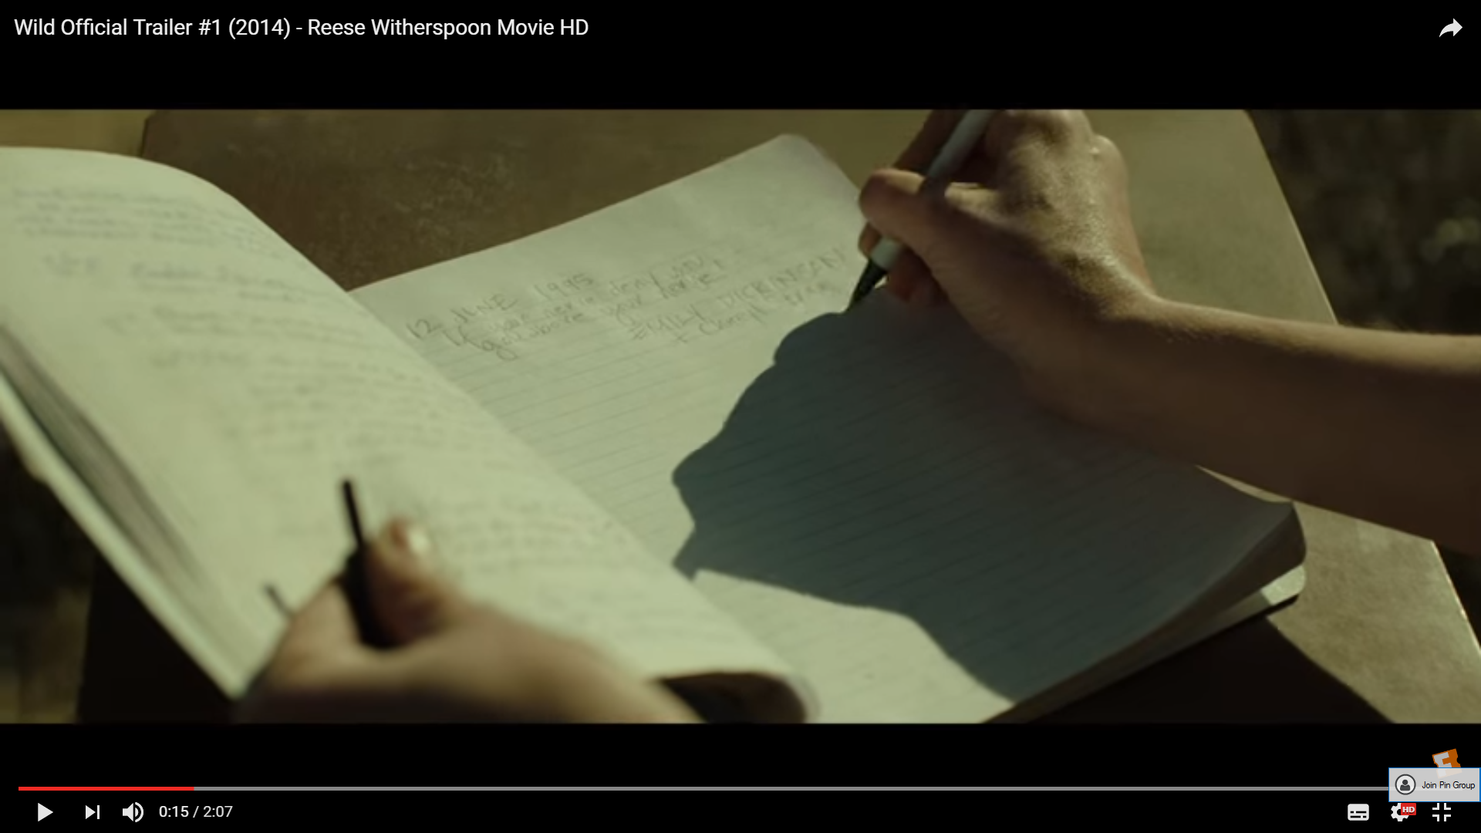

In this shot there are a combination of sound including the diegetic sound of the pen scratching on the paper as Cheryl is writing on the page and the faint sounds of the breeze – not allowing the audience to forget the setting. The sound of the pen against the paper is simultaneous to the voice over of the character saying what she is writing on the page. The colloquial tone to the dialogue of the voice over breaks the for the wall between the audience and the character, it’s as if Cheryl is directly talking to the audience, sharing her story – this immediately draws the audience in this interaction as they feel a part of it. The choice of words and descriptions of her feelings, also allows the audience to be able to relate to the character. The fact that it’s realistic and relatable is typical of the genre.

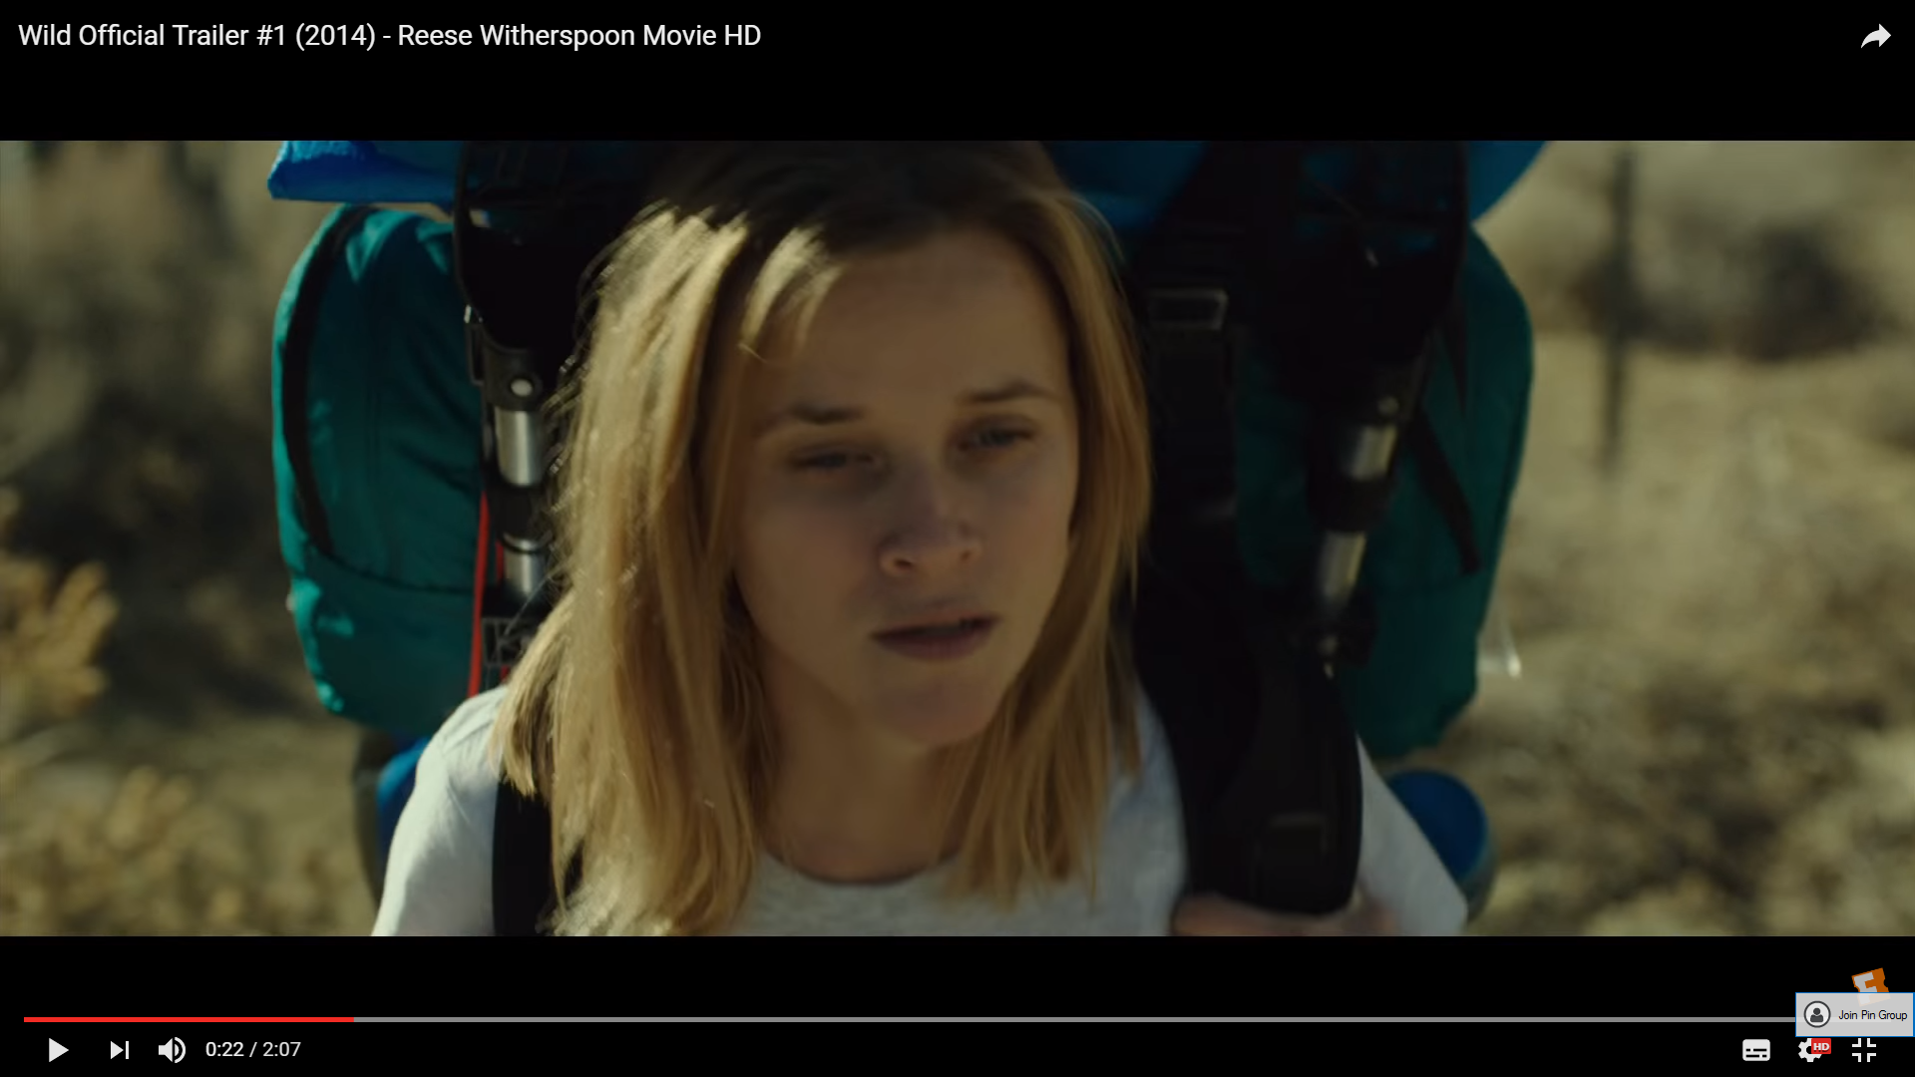

The close up allows the audience to be able to particularly focus on the characters face and try to imagine how she is feeling. This is a very common and well-established convention in drama films as the main focus is on creating a connection between the audience and the character so that they can experience whatever kind of journey that they’re going on together. This shot type is more effective in terms of audience response as they interact more with the visual aesthetics.
The casting of Reese Witherspoon in this role is also an important aspect as she is a well recognised star. Having someone such as Reese draws in more of an audience than just the fans of the novel (from which the film was adapted), it also attracts her fans. However, the target market and fan base is completely different from Reese’s fans as usually she plays a very different type of character – most recognised as the type of character from Legally Blonde, however, from the trailer alone, the audience are able to mature and be more serious in this drama alongside Reese Witherspoon and experience this physical, emotional and spiritual journey.

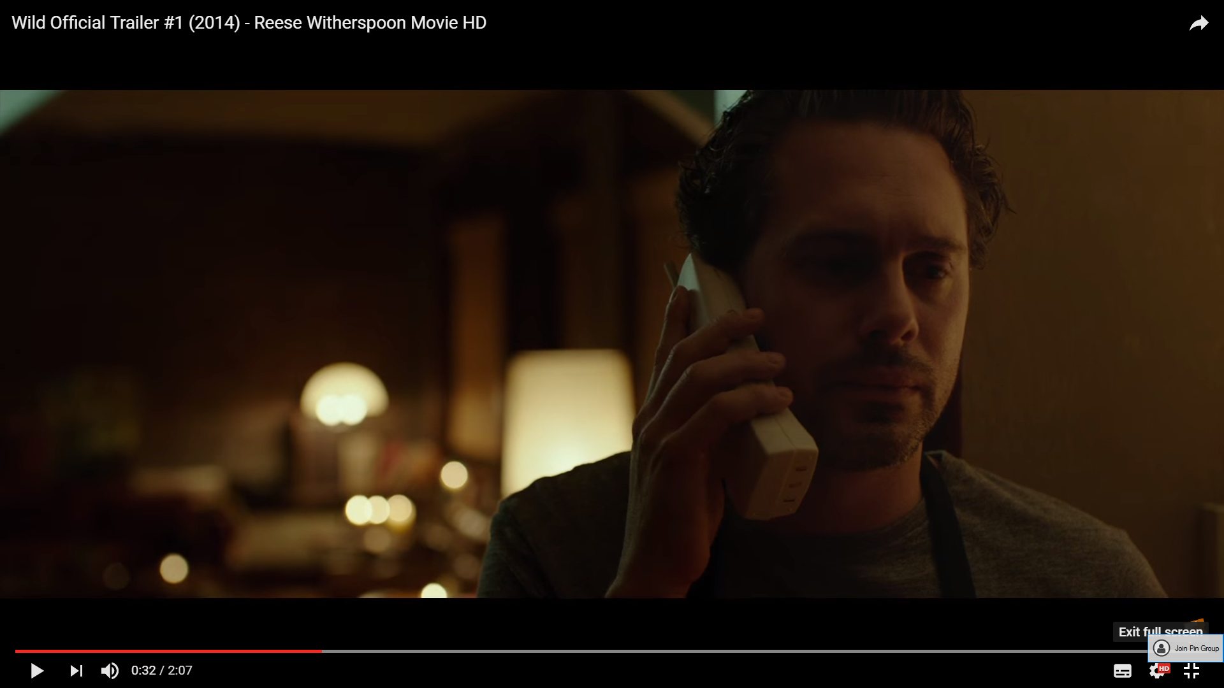
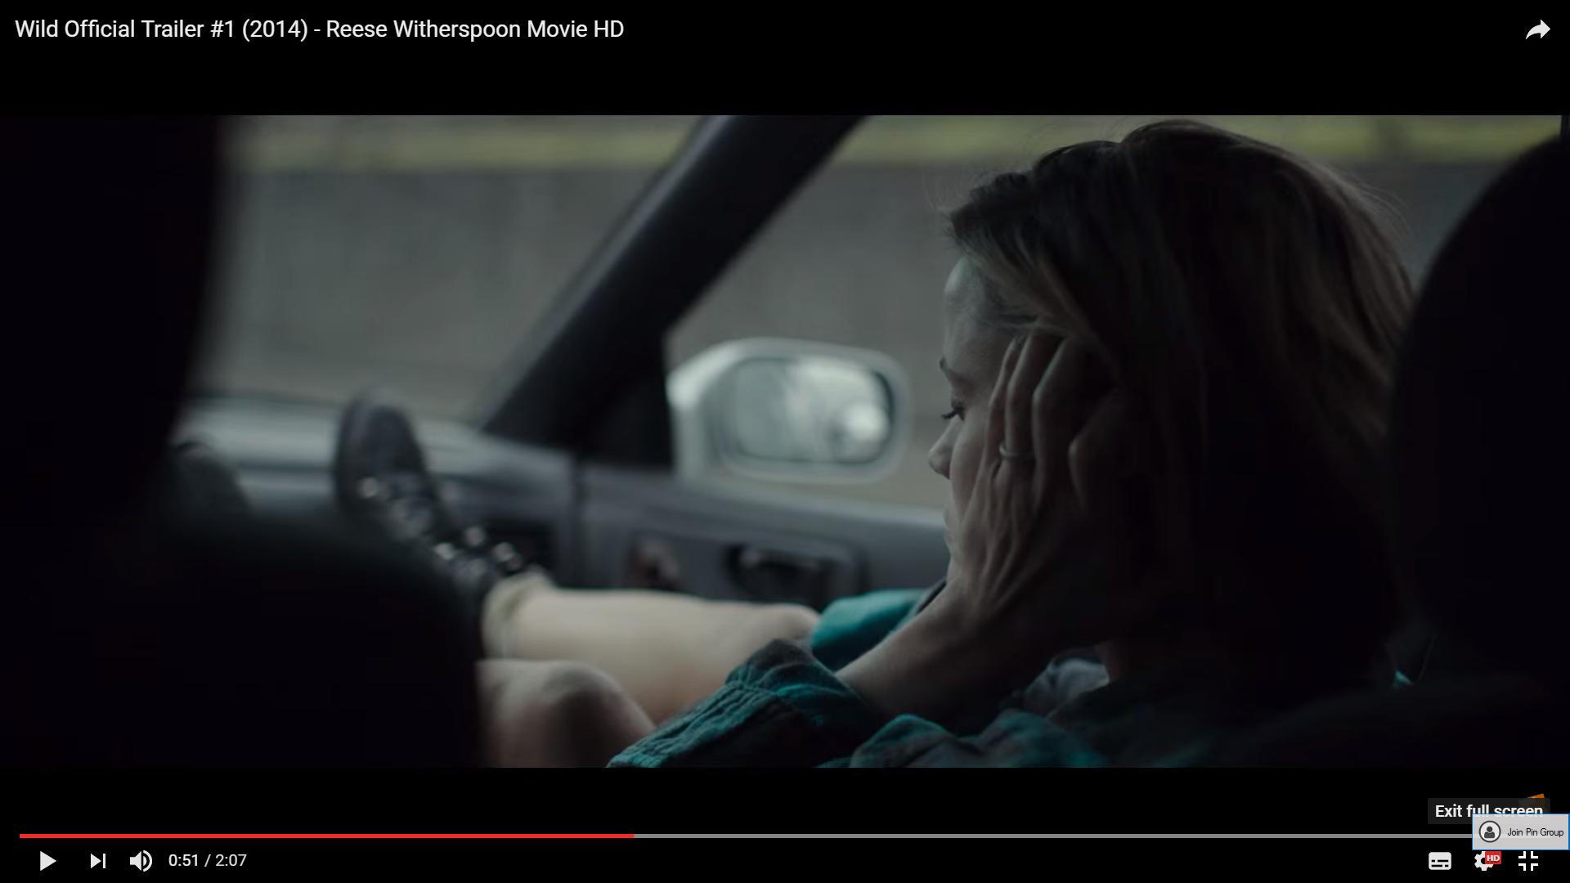
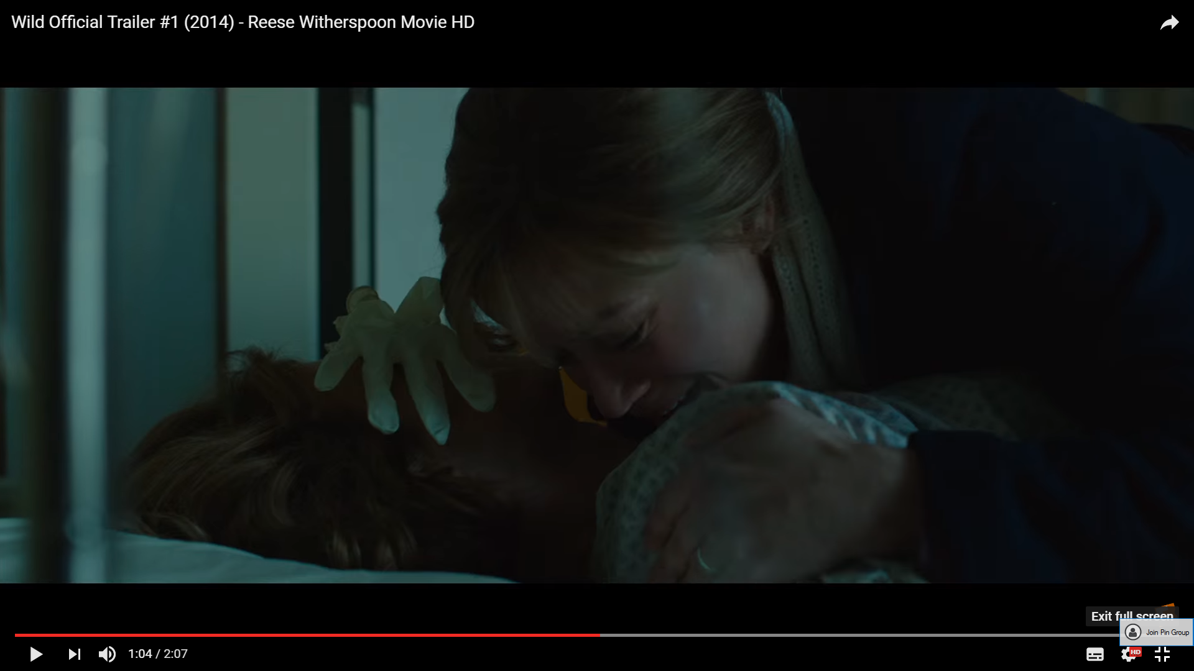

The mood created in each of this shots are distress. This is portrayed through the mise-en-scene, use of lighting as well as the characters themselves. The characters are marginalised in the frame. You either can't see them fully due to the lighting or an obstacle in the way. The marginalisation of the characters is an important feature as it adds to the atmosphere created. Furthermore, in the screenshots, the characters are positioned on the left of the frame. This could suggest that despite there obvious troubles through facial expressions as well as posture, they have free space around them .The world is still around them which provides a sense of serenity and hope. I could use this own technique in my own trailer as it would subliminally suggest that even though there are personal dramas, there is hope. Also the portrayal of distressed characters are a very common feature, it makes up part of the drama and therefore, I will also include a character in a similar state.

